### A. Datum Corporation

Level 11, 385 Queen St

Auckland Central, New Zealand 1010

Infrastructure Upgrade.

**Friday August 16, 2019**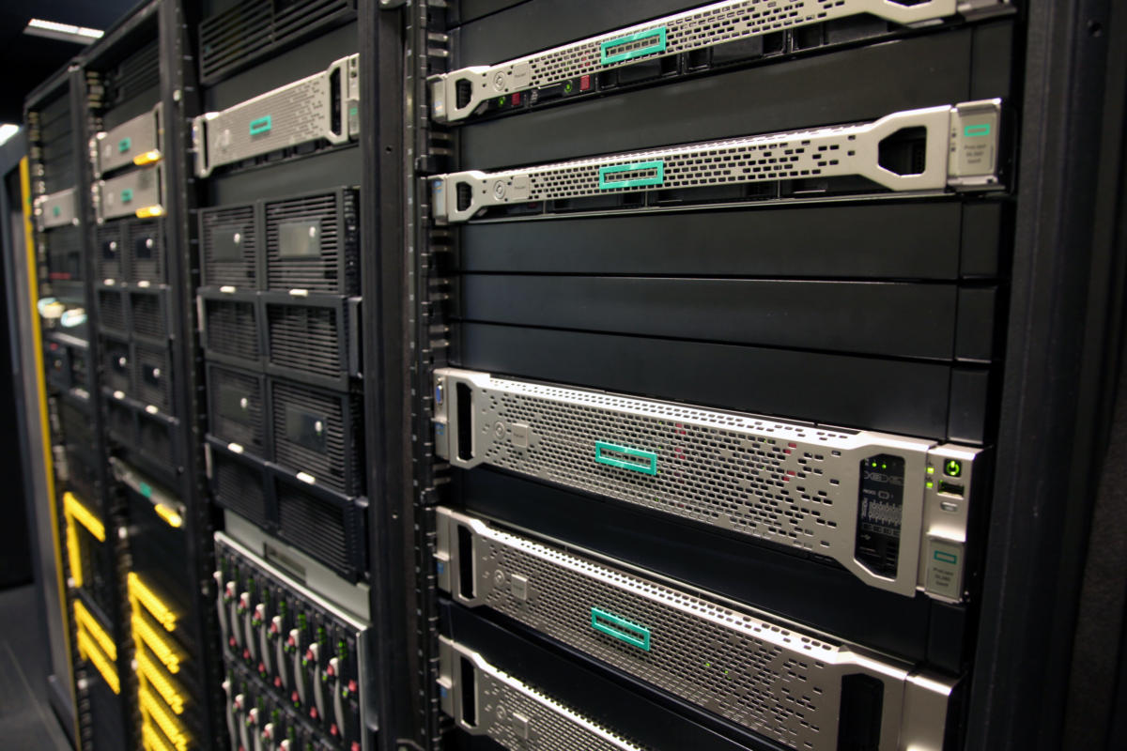

Brief.

Adatum is currently running a server 2003 R2 environment on x86 and they have a 2 domain controllers, 1 DNS server 1 DHCP server and 10 Clients Running windows 8.1. The company is wanting to upgrade to a server 2016 environment as the company is always expanding; it needs to be able to expand easily for new clients and can keep the whole infrastructure updated, as well as recover and still run in case of a failure

Server Hardware Upgrades.

Server: OS-Windows Server 2016 Standard.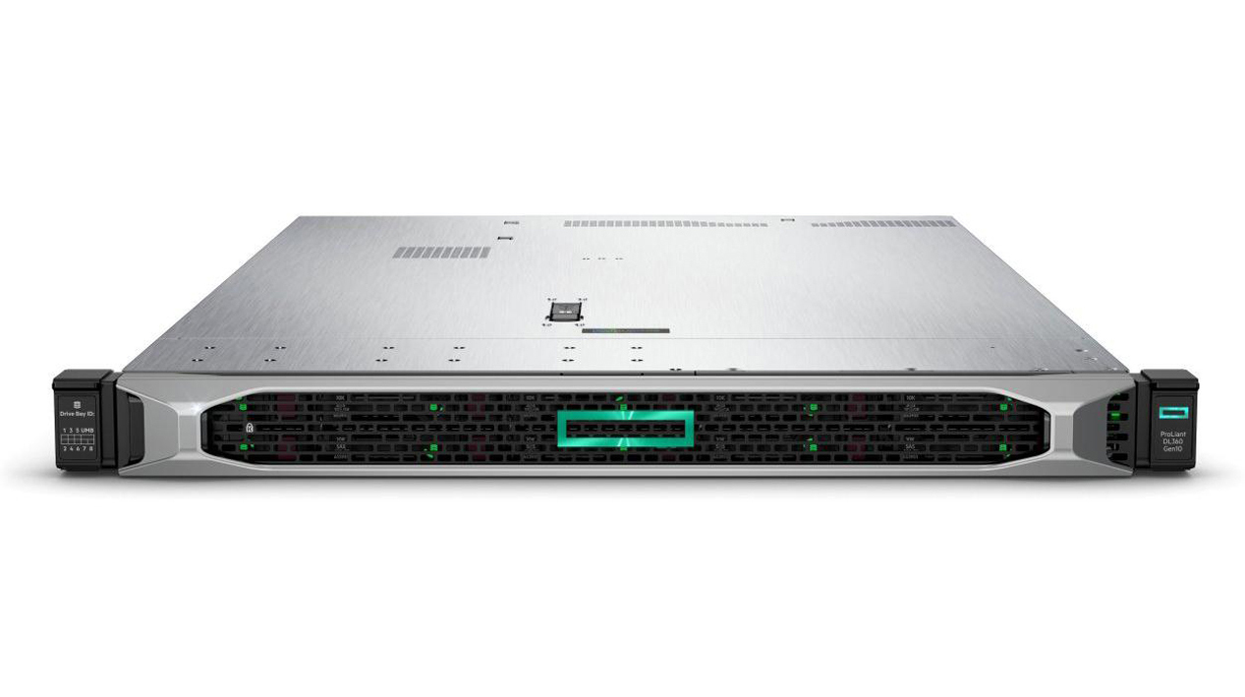

2x HPE ProLiant DL360 Gen10 :Intel® Xeon® Scaleable 4114 2.20 GHz, 13.75M Cache.

* Processor cache : 13.75 MB L3.
* Processor Name : Intel® Xeon® Scalable 4114 .(10 core, 2.2 GHz, 85W).
* Processor number : 1 processor.
* Processor speed : 2.2 GHz.
* Maximum memory : 768 GB, memory supported differs by processor selection.
* Memory type : HPE DDR4 SmartMemory.
* Memory, standard : 16 GB (1x 16 GB) RDIMM.
* Included hard drives : None ship standard, 8SFF drives supported.
* Security : Optional locking Bezel Kit, Intrusion Detection Kit, and HPE TPM 2.0.

Windows Server 2016 Standard

* Disaster Recovery - Automatic secure offsite data backup.
* Increased application uptime through multi-site failover clustering.
* Flexible and cost-effective data storage.
* Combine on-premises servers with cloud on your terms.
* Virtualize your applications to decrease costs and increase flexibility.

Backup Server.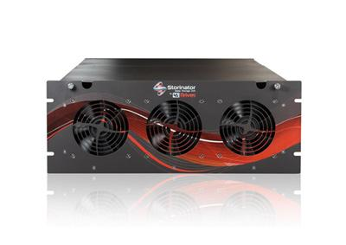

45 Drives Storinator Q30 Enhanced

* Power Supply:2N Redundant, High-Efficiency Power Supply.
* Motherboard: X10SRL (DDR 4).
* Processor: E52620 v4.
* RAM:32GB .
* Boot Drive:Single + Redundant SSD (120GB).
* HBA: 2 x LSI 9305 12Gb/s (SSD and SAS SATA Compatible).
* Operating System: Ubuntu.

Intel® Xeon® E5-2620v4 2.10Ghz, 20M Cache.

* Cores:8.
* Threads:16.
* Processor Base Frequency:2.10 GHz.
* Max Turbo Frequency:3.00 GHz.

Ubuntu Server 18.04.

Split File Shares [SAMBA SMB].

* DS40TB for backups [Space for 2 backups per server].
* 88TB for archival .
* Improved performance on small-CPUs.
* Improved TDB database performance (using robust mutex locking) .
* Its has six months fully supported updates .
* Another six months in the maintenance mode
* Always six months in the security fixes only mode.

Backup Server Cont.

32x- Seagate Exos 4TB HDD (Exos 4TB (ST4000NM0015) )

* HDD Capacity:4TB HDD.
* Form Factor:3.5".
* RPM:7200RPM.
* Cache:128MB
* Interface:SATA3.
* Reliable access to unstructured data in bulk storage applications.
* 12Gb/s SAS and SATA 6Gb/s interfaces in industry-standard format for easy integration into replicated and RAID multi-drive storage servers and systems.
* Consistent performance in dense multi-drive systems.

Software.

Windows Server 2016

Features we are using.

DHCP Server.

The DHCP Server gives client computers a lease ip so they can connect to the internet .

DNS Server.

The Active Directory creates authentication, updating, or searching, computers by using DNS .Server to locate Domain controller. The domain controller use a DNS server to trace other computers.

Active Directory Domain Services/

A server running Active Directory Domain Services is called a domain controller. It authenticates all /users and computers in a Windows domain type network assigning and enforcing security policies /for all computers and installing or updating software. Active Directory checks the submitted /password and searches the database if the user is an administrator account or normal user account. /Also, it allows management and storage of information, provides authentication and authorization mechanisms.

Source: [Wikipedia](https://en.wikipedia.org/wiki/Active_Directory)

VPN

The Remote Access Service is used as a single tenant gateway for the VPN server that could provide many advance features and functionality. Users can access Local data servers by connecting to locally hosted VPN server. This makes it so users can access the data offsite.

Server Room Requirements.

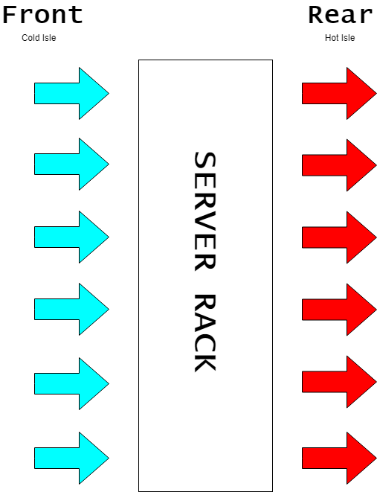

# Cooling

## Airflow.

Air conditioning is placed in front of the rack where the servers pull in cold air and hot air gets exhausted out the back

Internet.

# [Spark Business UFB](https://www.spark.co.nz/business/shop/internet/plans-and-pricing/)

950 Download 450 Upload.  
Free Static IP.

$172.33 plus GST

Computers.

|  |  |  |  |  |
| --- | --- | --- | --- | --- |
| Type | Name | Cost | Total | Store |
| CPU | [Intel Core i5-8400 2.8 GHz 6-Core Processor](https://www.pbtech.co.nz/product/CPUIT8403/Intel-Coffee-Lake-Core-i5-8400-6-Core-28Ghz-9MB-Ca?qr=pspy) | 316.25 | 316.25 | PB Tech |
| CPU Cooler | Intel Stock Cooler | 0.00 | 316.25 | 1st Wave |
| Motherboard | [Asus PRIME H310M-K Micro ATX LGA1151 Motherboard](http://1stwave.co.nz/catalog/index.php?main_page=product_info&cPath=35_60&products_id=1700) | 98.00 | 414.25 | 1st Wave |
| Memory | [Kingston FURY 8 GB (2 x 4 GB) DDR4-2666 Memory](https://1stwave.co.nz/catalog/index.php?main_page=product_info&cPath=17_43&products_id=1328) | 92.00 | 506.25 | 1st Wave |
| Storage | [Samsung 860 Evo 500 GB 2.5" Solid State Drive](https://1stwave.co.nz/catalog/index.php?main_page=product_info&cPath=63&products_id=1615) | 113.00 | 619.25 | 1st Wave |
| Case | [Cooler Master MasterBox Lite 3 MicroATX Mini Tower Case](https://www.pbtech.co.nz/product/CHACLM10325/Cooler-Master-MasterBox-Lite-3-MATX-Gaming-Case-MB?qr=pspy) | 67.85 | 687.10 | PB Tech |
| Power Supply | [Corsair CX (2017) 550 W 80+ Bronze Certified ATX Power Supply](https://www.pbtech.co.nz/product/PSUCOR73801/Corsair-CX-Series-CX550-550W-80-Plus-Bronze-Power?qr=pspy) | 98.99 | 786.09 | PB Tech |
| Monitor | [Asus VP228H 21.5" 1920x1080 60 Hz Monitor](https://www.pbtech.co.nz/product/MONAS53280/ASUS-VP228H-215-Full-HD-Gaming-Monitor-1ms-HDMIDVI?qr=pspy) | 166.75 | 952.84 | PB Tech |
| Keyboard Mouse Combo | [Logitech MK120 Desktop Kit, USB Keyboard + Mouse](https://www.mightyape.co.nz/product/logitech-mk120-desktop-kit-usb-keyboard-mouse/8174702?gclid=Cj0KCQjwv8nqBRDGARIsAHfR9wAsXwN8KQxiip1VqFee4KP3EcTYFVDW7DKTHRXMik_hrDym9DUpZFUaAvnUEALw_wcB) | 27.00 | 979.84 | Mighty Ape |

If Users need extra storage the have an extra 7.84TB (-Filesystem overhead) on the server that they can use .

Privacy and Security

## Privacy

## Disk Destruction

[Kill Disk](https://www.killdisk.com/eraser.html)

* Kill Disk is an affordable industrial-grade disk sanitation hardware solution combined with Industrial Software and supporting parallel erasure of up to 25 HDD/SSD disks.
* Rack mountable solutions, 3U & 4U form factors.
* Customizable, quiet & energy efficient
* Supports fully automated operations.
* Licensing policy assumes no extra costs per disk erase!

## Security Cameras

[UniFi Video IP Camera G4 Pro](https://gowifi.co.nz/ipnetworkvideocameras/uvc-g4-pro.html)

# Security

RFID Cards (for entrance to building)  
Biometrics (to enter server room)

Health and Safety

Server Room (Hazards)

* Tripping hazards
* Electricity
* Fans
* Eating food
* Drinking water
* Temperature

Office (Hazards)

* Chairs and tables
* Tripping hazards
* Not blocking the exits
* Sickness\injuries
* Children
* Poor posture
* Eye strain

How are we going to achieve Health and Safety in the Office or Server Room

* Evaluation plan\procedures
* Having fire extinguisher
* Having First aid kit
* Having exit signs placed
* Having a fire alarm system in place
* Assign a person to be a fire warden
* Having an Evaluation Meeting Point planned
* Don’t use evaluators use stairs
* Go to the closest emergency exit
* Have a meeting to discuss about health and safety

Costs.

|  |  |  |  |  |
| --- | --- | --- | --- | --- |
| Quantity | Product | Cost Each | Cost (NZD) | Total (NZD) |
| 1 | [45 Drives Storinator Q30 Enhanced](https://drive.google.com/file/d/1qZ9bZ4Qw3U70N7Svv0aa3IEyWNsUf3u6/view) | 18671.81 | 18671.81 | 18671.81 |
| 2 | [Windows Server 2016 Standard](https://www.softwaregiants.com/en_nz/windows-server-2016-standard.html?gclid=CjwKCAjw1f_pBRAEEiwApp0JKA162WUsKrgDr1rm-jevKQoo0Esp6rT_JIUBv_I7yqqJBBILpOkIMhoC4dAQAvD_BwE) | 799.99 | 1599.98 | 20271.79 |
| 2 | [HPE ProLiant DL360 Gen10](https://buy.hpe.com/pdp?prodNum=867962-B21&country=nz&locale=en&catId=15351&catlevelmulti=15351_3328412_241475_1010007891) | 5509.82 | 11019.64 | 31291.43 |
| 1 | [Ubuntu Server 18.04](https://ubuntu.com/download/server) | 0 | 0 | 31291.43 |
| 10 | [Windows 10 Pro](https://www.pbtech.co.nz/product/OSYMST3706/Microsoft-Windows-Professional-10-32-bit64-bit-Eng) | 320.85 | 3208.5 | 34499.93 |
| 16 | [HPE 900GB Enterprise Hard Drive](https://buy.hpe.com/pdp?prodNum=870759-B21&country=nz&locale=en&catId=329290&catlevelmulti=329290_329233_7101711_1009689640) | 1460.90 | 23374.44 | 57874.37 |
| 10 | [Custom Bulid PC](https://nz.pcpartpicker.com/list/Mrp4RJ) | 979.84 | 9798.4 | 67672.77 |
| 2 | [Eaton 9PX 3000VA 2U Rack/Tower, 16Amp Input, 230V](https://www.pbtech.co.nz/product/UPSPWR0006/Eaton-9PX-3000VA-2U-RackTower-16Amp-Input-230V-Rai) | 4,312.50 | 8625 | 76297.77 |
| 1 | [Dynamix 37RU Server Cabinet](https://www.pbtech.co.nz/product/CHADNX3703/Dynamix-37RU-Server-Cabinet-1000mm-Deep-600x1000x1) | 1,166.00 | 1166 | 77463.77 |
| 1 | [XG-1541 1U pfSense® Security Gateway Appliance](https://www.netgate.com/solutions/pfsense/xg-1541.html) | 4712.5 | 4712.5 | 82176.27 |
| 1 | [Ubiquiti UniFi Controller Cloud Key G2 with 1TB HDD](https://gowifi.co.nz/videosurveillance/uck-g2-plus.html) | 431.25 | 431.25 | 82607.52 |
| 1 | [EdgeSwitch 16 XG](https://www.gowifi.co.nz/nonpoe/es-16-xg.html) | 1144.25 | 861.35 | 83468.87 |
| 1 | [EdgeSwitch 48 Lite](https://gowifi.co.nz/switches/es-48-lite.html) | 861.35 | 861.35 | 84330.22 |
| 1 | [EdgeSwitch 48 (500W PoE | 24V Passive | 802.3af/at)](https://gowifi.co.nz/switches/es-48-500w.html) | 1696.25 | 1696.25 | 86026.47 |
| 5 | [UniFi Video IP Camera G4 Pro](https://gowifi.co.nz/ipnetworkvideocameras/uvc-g4-pro.html) | 891.40 | 4457.00 | 90483.47 |
| 1 | [Ubiquiti 4x4 MU-MIMO Wave 2 802.11ac Access Point 3 Pack](https://gowifi.co.nz/wireless/uap-nanohd-3.html) | 891.40 | 891.40 | 91374.87 |
| 1 | [Spark Business Fibre Max](https://www.spark.co.nz/business/shop/internet/plans-and-pricing/) | 172.33 | 172.33 | 91547.20 |
|  |  |  | Sub Total | 77815.12 |
|  |  |  | GST | 13732.08 |
|  |  |  | Final Total | 91547.20 |
|  |  |  |  |  |
|  |  |  |  |  |

